SMART SOLUTION FOR RAILWAYS

TEAM ID:PNT2022TMID35794

SPRINT-3: BOOKING AND QR:

NODE RED:

BACK-END SCREENSHOTS:
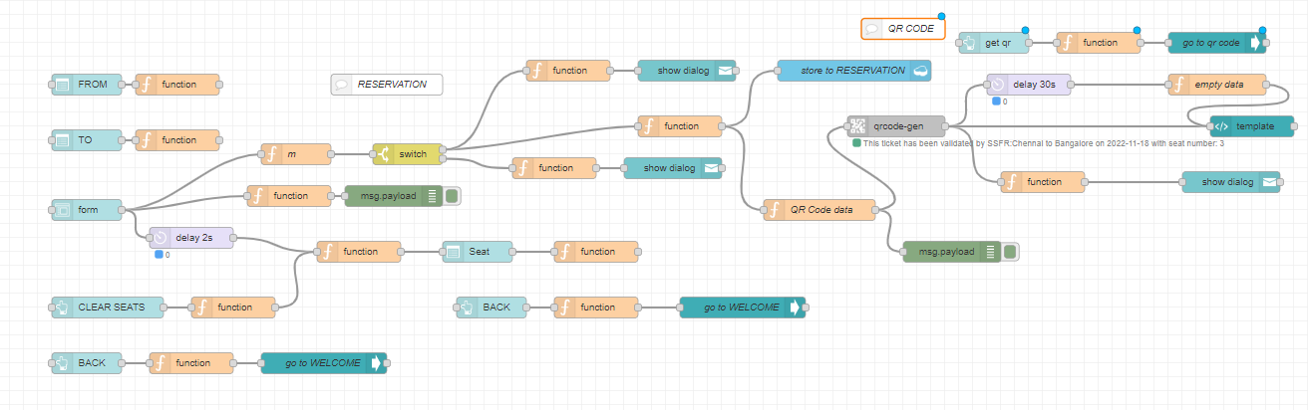

RESERVATION SCREEN:
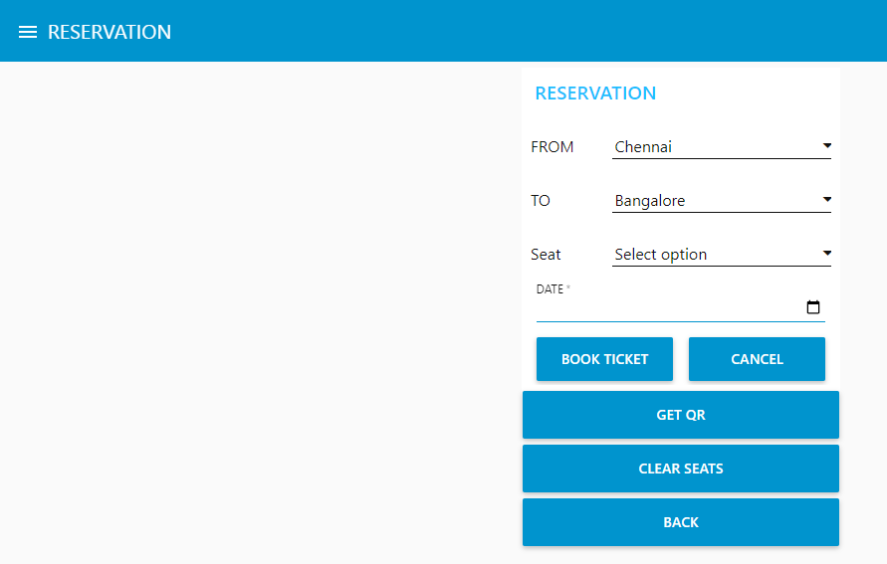

QR CODE SCREEN:
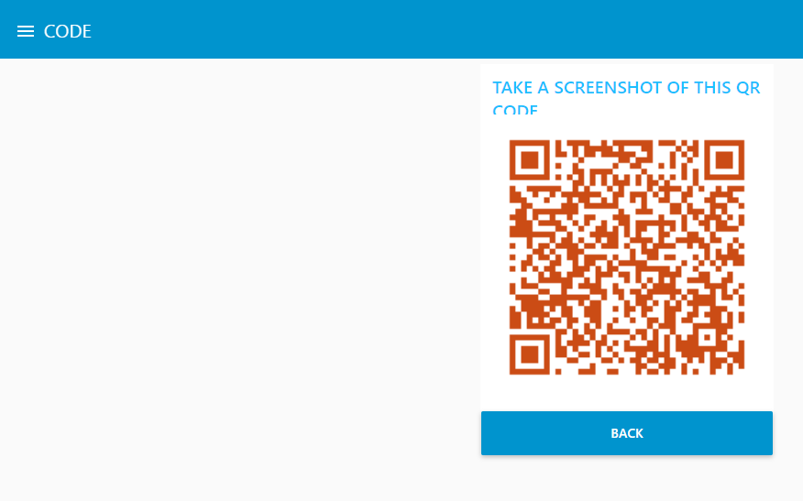

IBM CLOUDANT STORAGE:(STORE TO reservation)
